

PROJECT DESIGN
COURSE: SWE3090A
SEMESTER: FALL 2026
INSTRUCTOR: DR. FREDRICK OGORE
NAME: JOY WANJIRU NDUNG’U
ID: 671500
Machine Learning-Assisted Emergency Department Triage and Resource Allocation System
(TRAS)

Note on Design Refinement
After submission, a consultation with an emergency nurse, as planned in Section 3.2, validated the ED workflow in practice: patients receive a token on arrival, a nurse records their vitals, doctors call patients by token and determine severity, and the nurse in charge allocates rooms. Doctors move around the ward and are not assigned by the nurse in charge. In keeping with the iterative approach described in Section 3.1, the system design was refined to reflect this: the Head Nurse role became the Nurse in Charge, a Doctor role was added to review and confirm the predicted severity, the allocation recommendation was limited to rooms, and a prioritized waiting queue was introduced. The core of the project is unchanged: explainable machine-learning severity prediction, a rule-based allocation algorithm, and a real-time advisory dashboard with human oversight.

Login Screen
Staff sign in with their email and password, and the system then opens the screens permitted for their role
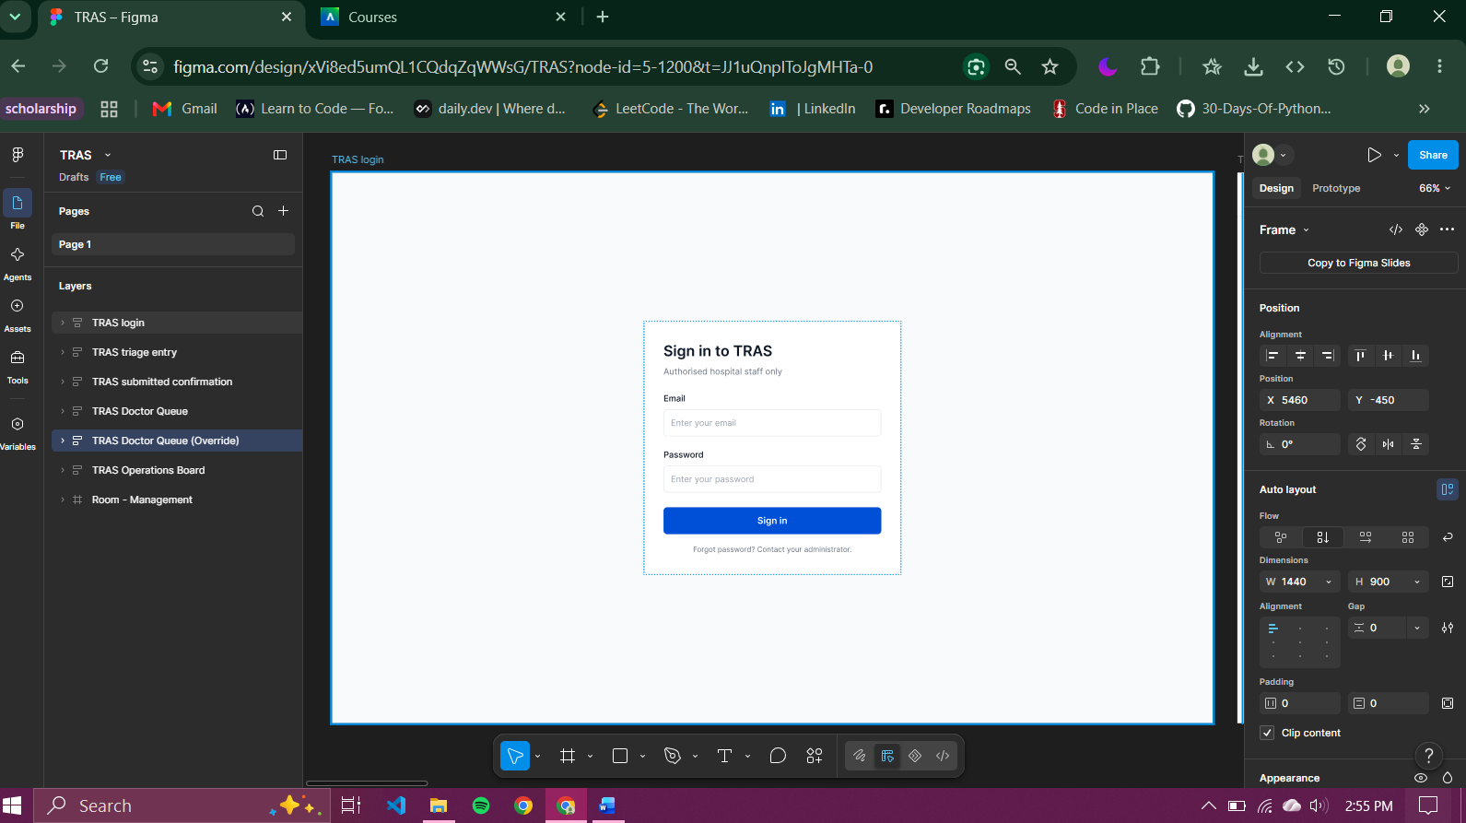
Figure 1 Login Screen

Triage Entry ( Triage Nurse)
The triage nurse enters the patient’s token number, age, vital signs, level of consciousness, and chief consultant, and submits the record.
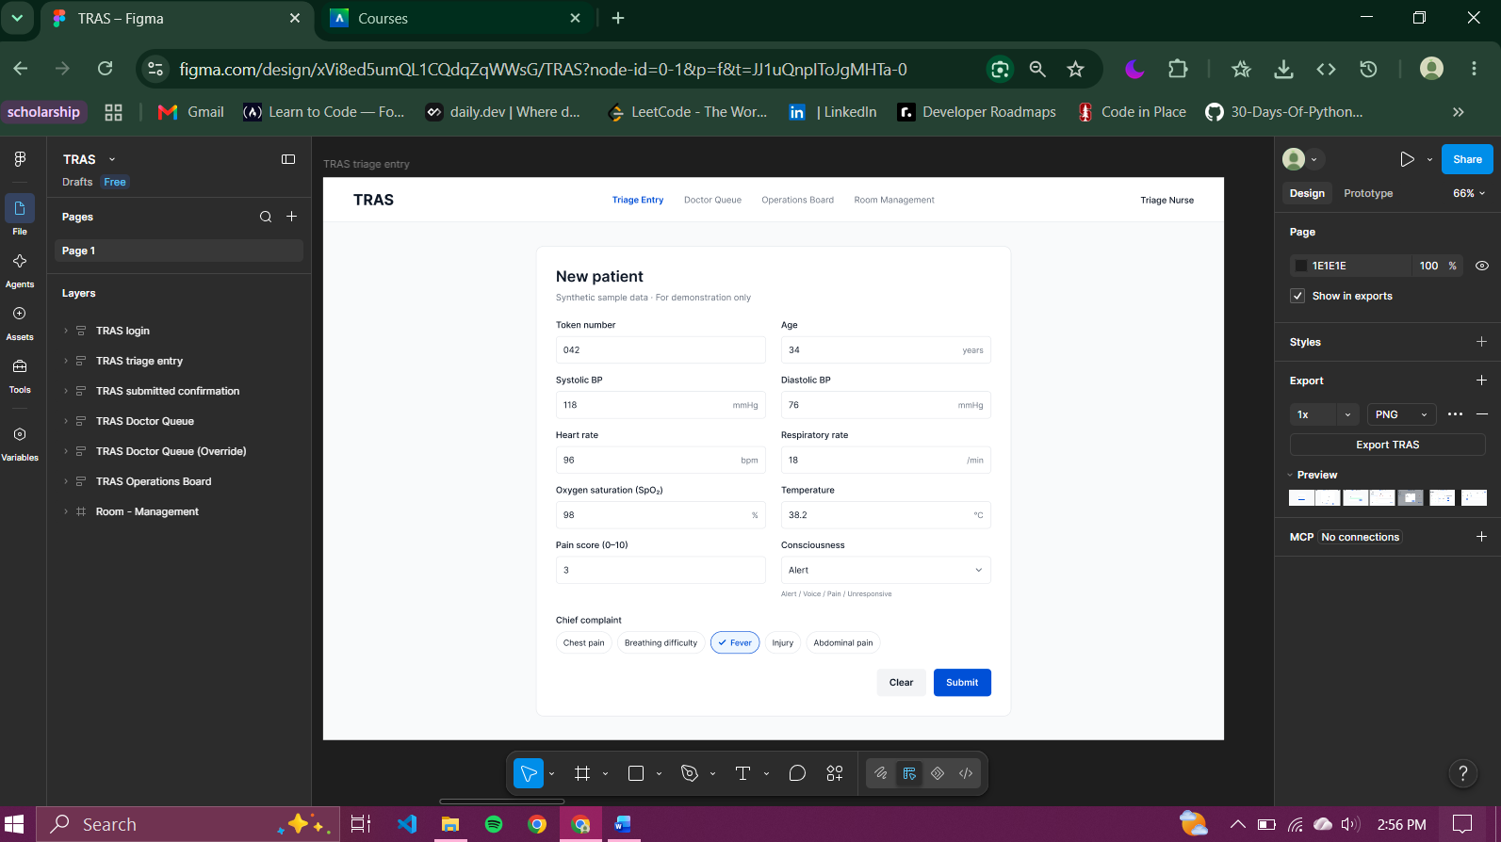
Figure 2 Triage Entry

Triage Entry Confirmation
A confirmation then shows that the token has been queued for doctor review.
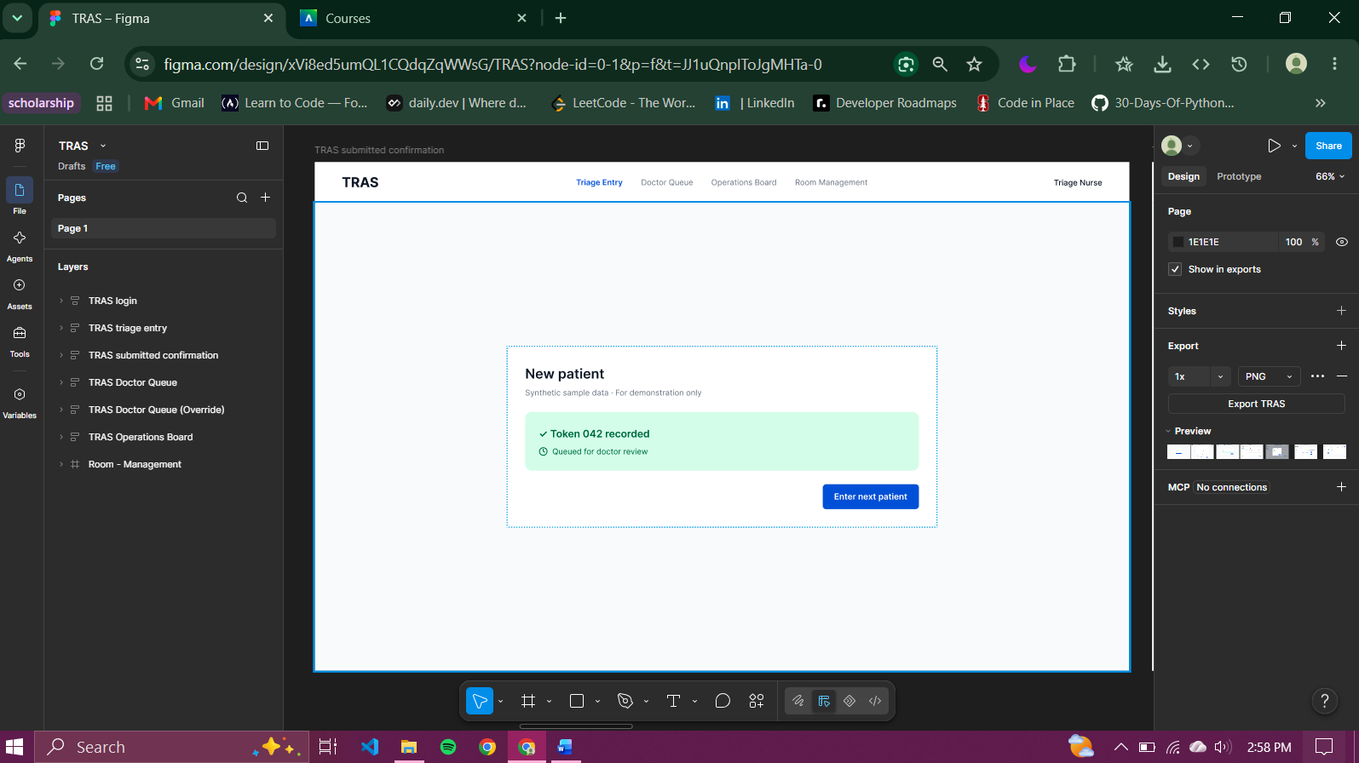
Figure 3 Triage Entry ( Confirmation)

Doctor Queue
The waiting queue is arranged by predicted severity, then by waiting time, so critical patients appear first even if they arrived after stable patients. For the selected patient, the doctor sees the vital signs with abnormal values flagged, the predicted severity with its confidence, and the main factors behind the prediction.
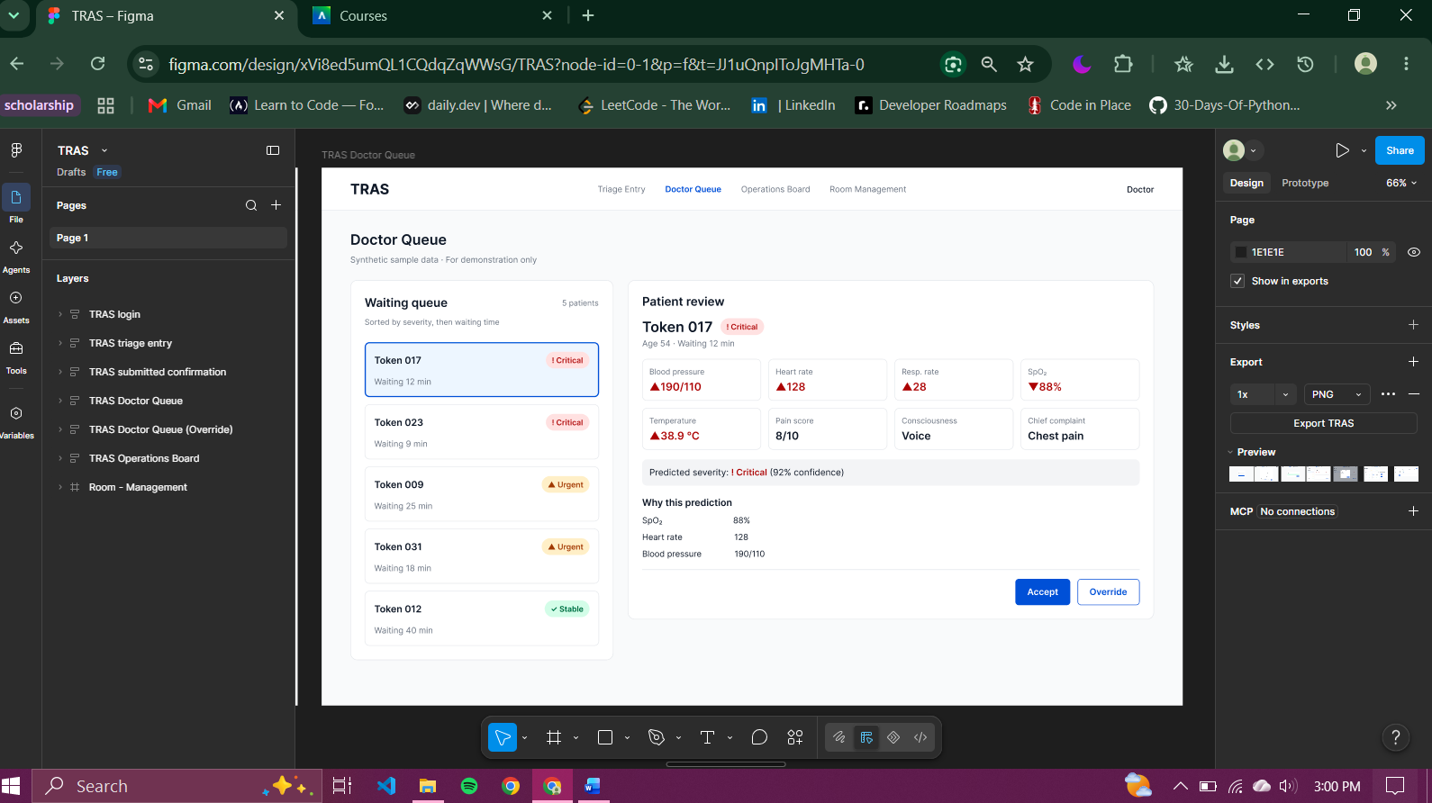
Figure 4 Doctor Queue

Doctor Override Dialog
The doctor accepts the prediction or overrides it, providing a reason; the prediction remains advisory, with the clinician retaining the final decision.
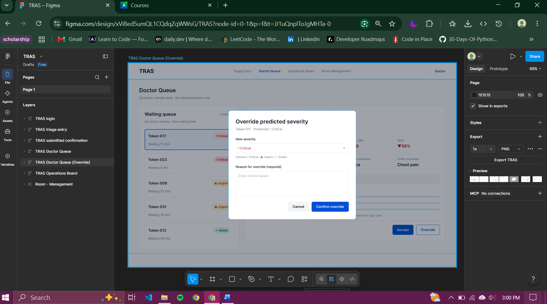
Figure 5 Doctor Override Dialog

Operations Board
The board shows the number of patients waiting at each severity level, the status of every room, and the pending room recommendations generated by the allocation algorithm. The nurse in charge confirms, modifies, or rejects each recommendation, and updates appear for all users without a page refresh.
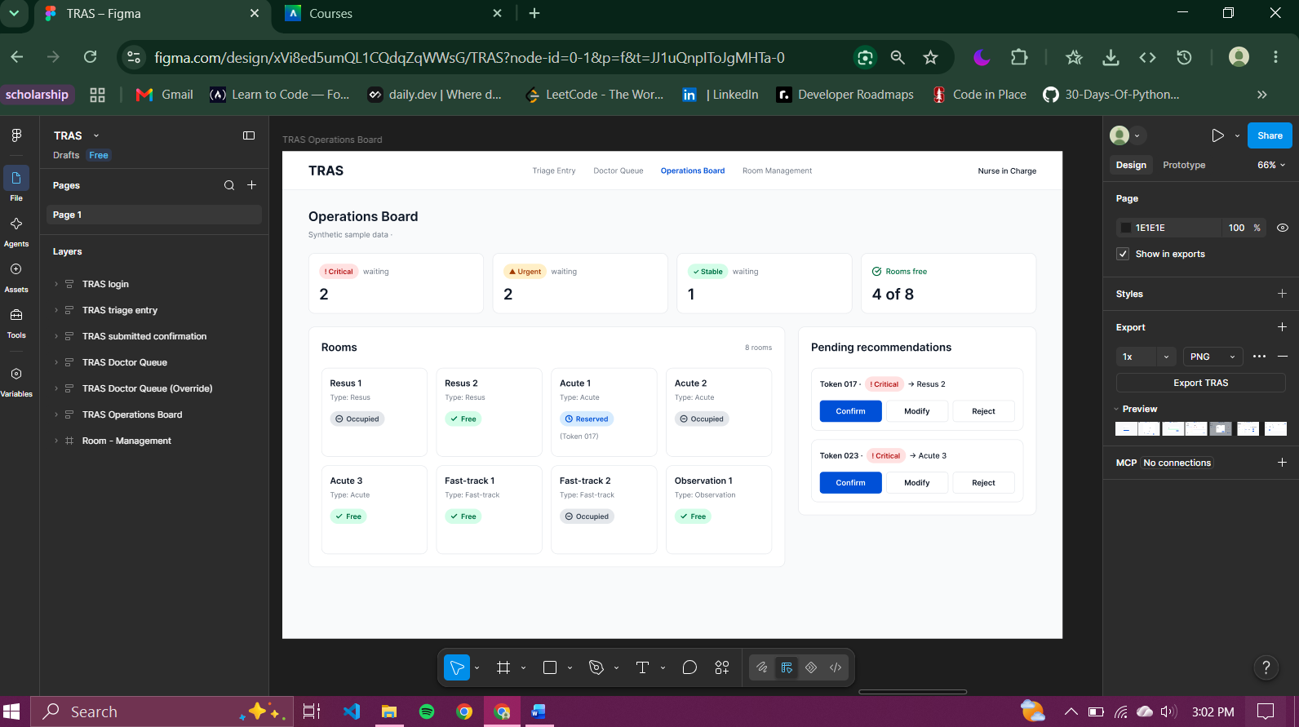
Figure 6 Operations Board

Room Management
The nurse in charge adds and edits room records and records each patient’s outcome (admitted, discharged, or transferred) so that the room is released and the board stays accurate.
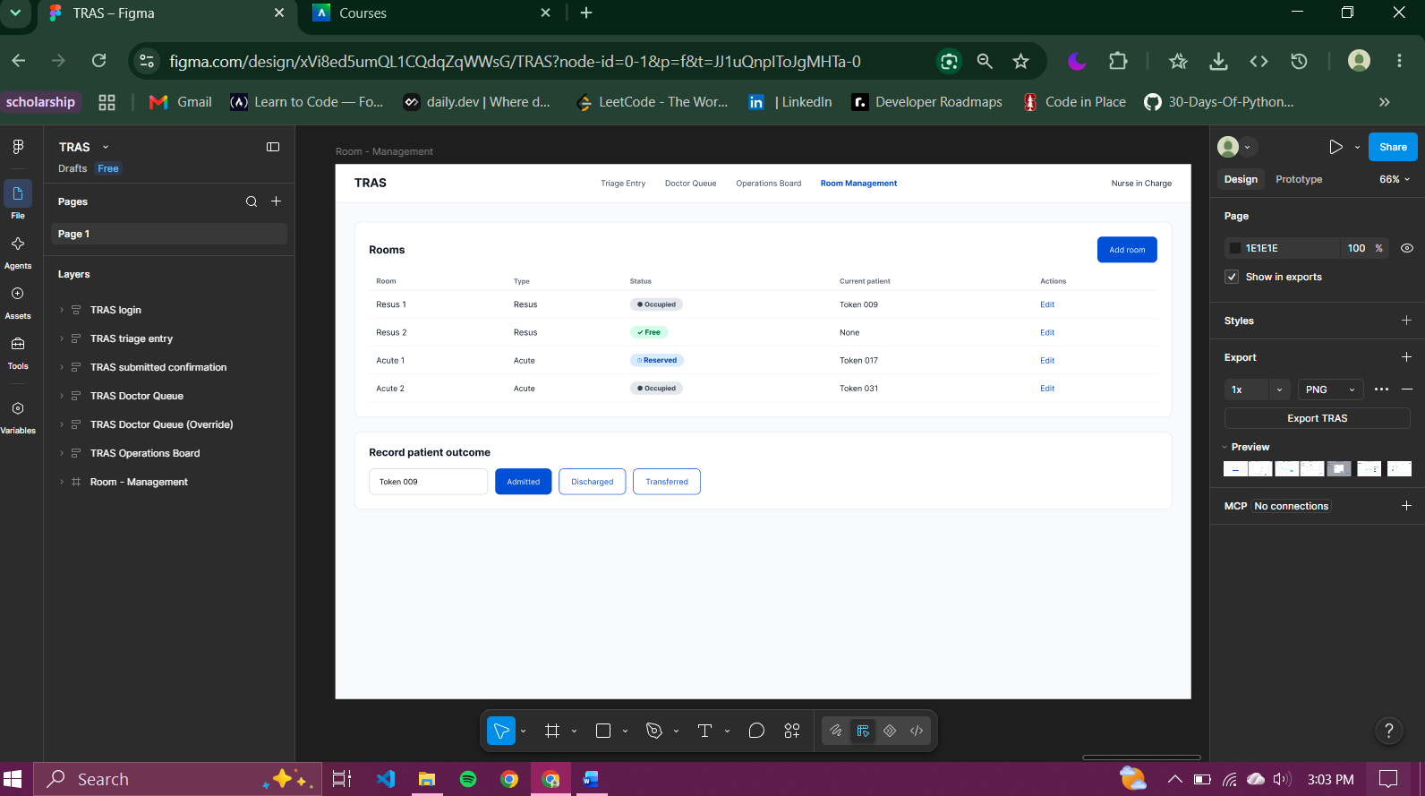
Figure 7 Room Management

